Filtering
Part 1
This lab deals with the filtering of signals. We filter signals to remove or modify certain frequency components within a signal. This essentially isolates the portion of the signal we deem meaningful. Filtering has many applications, such as noise reduction, signal enhancement, etc. We will design an IIR filter in the first experiment.

Experiment 1 – Notch Filter Design
    - Create a new pure Python file, and load the with_hum.wav audio file. Similar to experiment 2 of lab 2.
    - Play it and observe the difference between the two audio files.
    - Plot the frequency response (frequency domain) of the with_hum file.
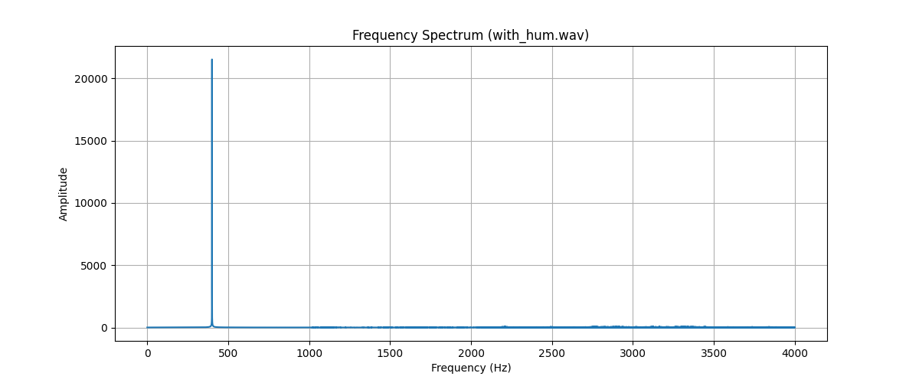
    - You should observe that at 400Hz, the magnitude is far greater than the other frequencies. Compared to the other audio file, you should observe that the peak amplitude (magnitude) was about close to 300 at a frequency close to 3200Hz.
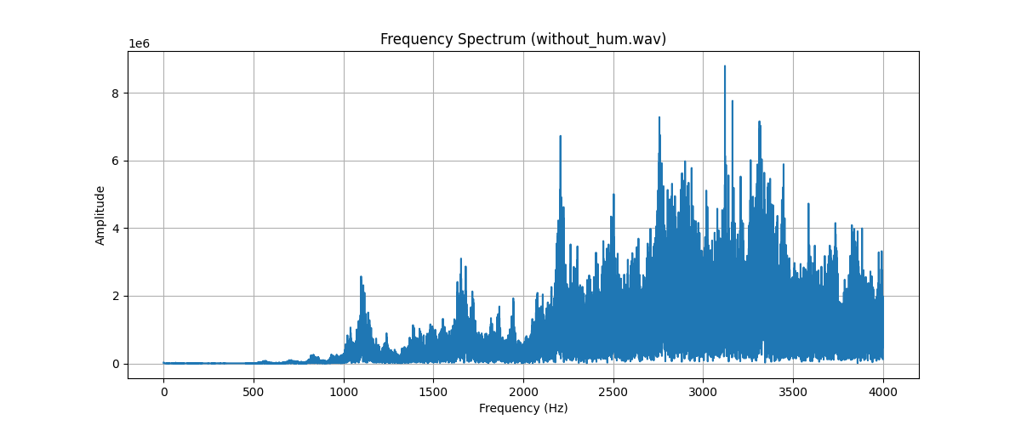
    - We will filter out the 400 Hz humming interference using a Notch Filter filter to suppress signals around that frequency.
    - First, include the following libraries from scipy.signal butter, freqz, filtfilt
- from scipy.signal import butter, freqz, filtfilt
7) Read on butter, and freqz from the links attached to further understand the parameters and how the functions work to implement the notch filter designs.
8) Use the code below to design and plot the frequency response of the filter. You should see a plot with a dip around the targeted frequency.
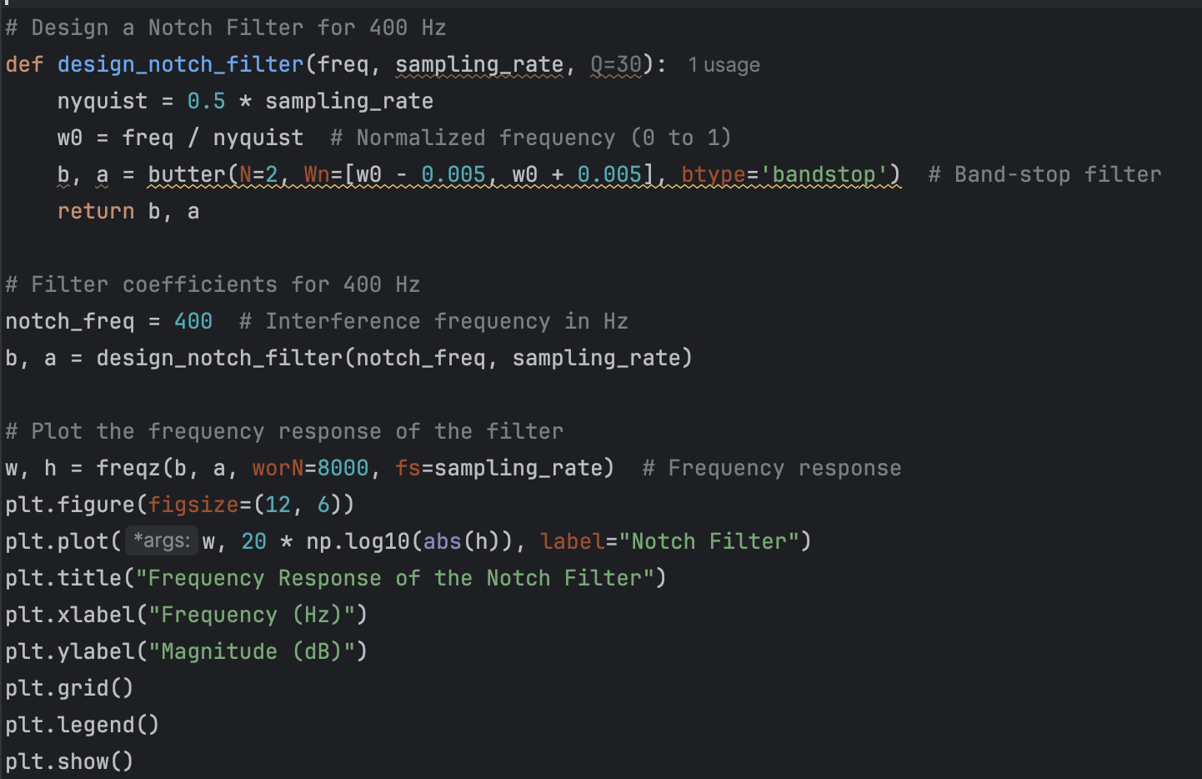
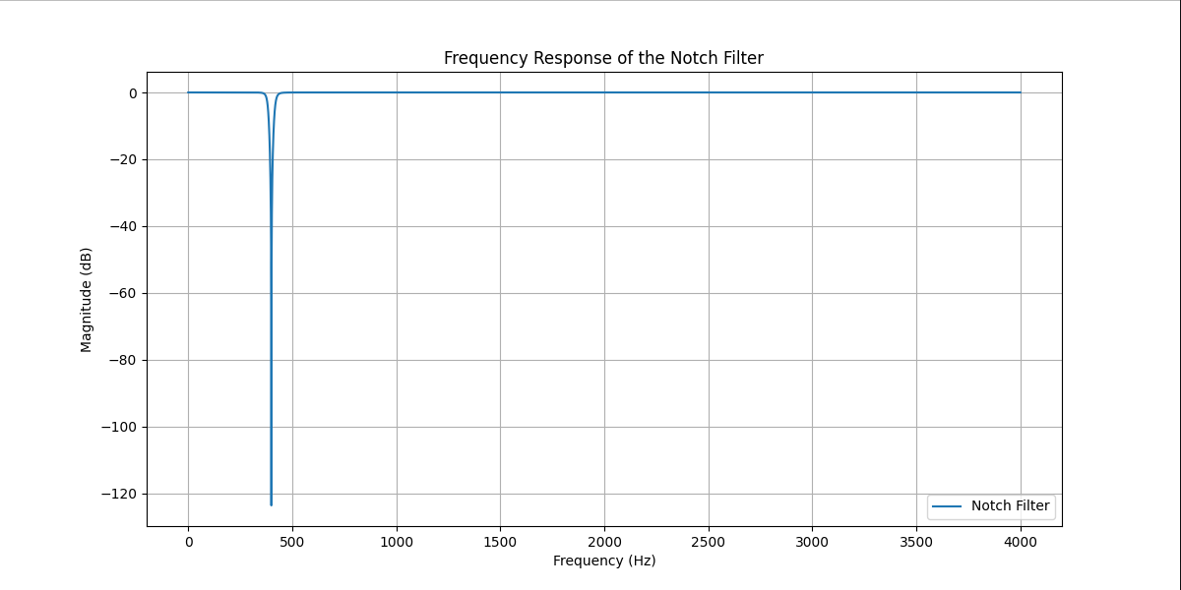
9) Apply the filter to the audio, observe the change, and plot the frequency response with the following lines of code.
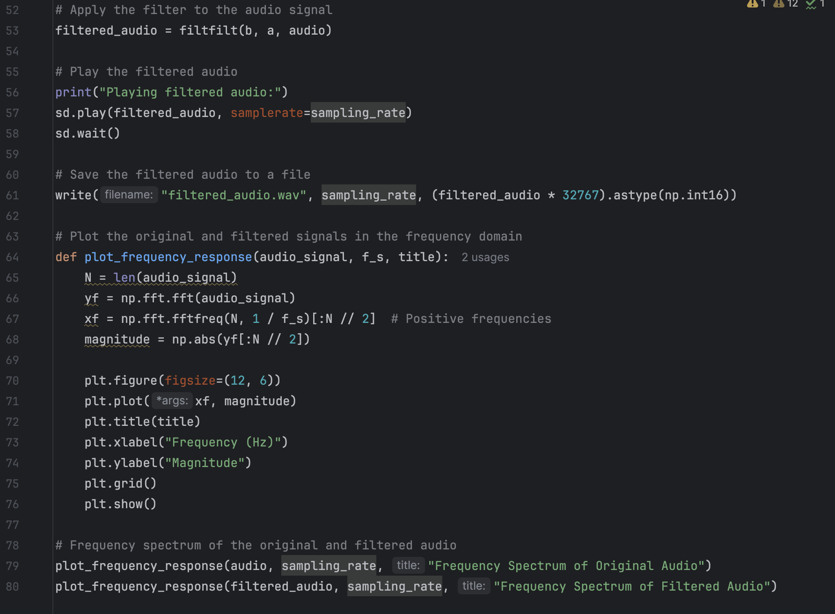
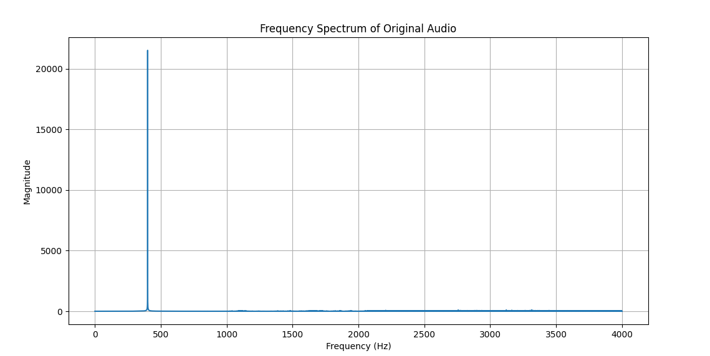
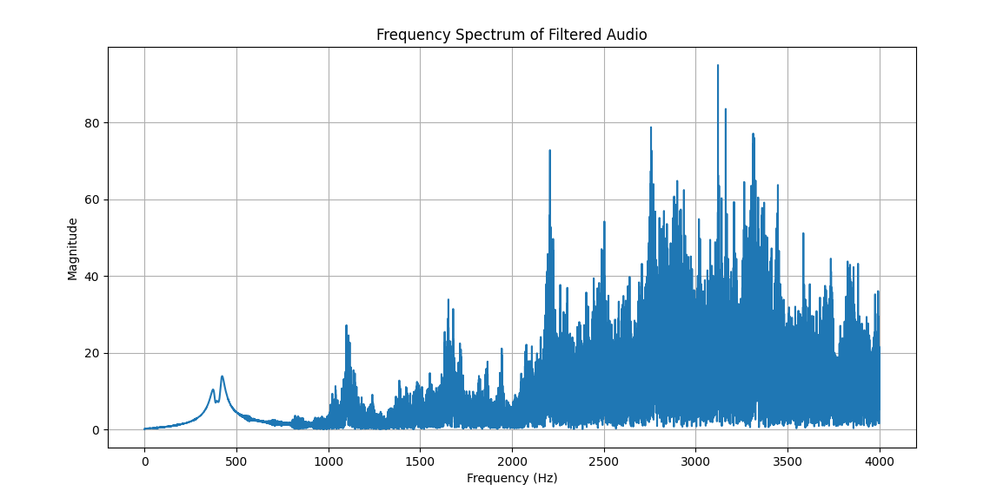
Assignment 1 - Run the code from the experiment, answer the following, and attach the plots to your lab report.

    - What is the order of the filter?
Order 2
    - Could you achieve the same effect with a higher or lower order? (Modify the code to observe the effects. You do not have to show the plots of this.)
Increasing the order to 4 achieves a similar spectrum with more accurate suppression around the 400 Hz range.
    - What are the practical effects of using both cases from question 2?
Increasing order has the benefit of more accurate suppression, but with diminishing returns as the music is no longer hearable or cause audible ringing sounds. Decreasing the order can reduce the strength of the filter making the transition from passband to stopband more gradual but it makes suppression less accurate.
    - What is the difference between taps and orders?
Orders determine the strengh of the attentuation within a IIR filter using previous outputs as increasing it accurately attenuates the frequency range while keeping other frequencies untouched. Taps are the coefficients within a FIR filter representing a constant multipier of the delays of the previous inputs where increasing the number of taps can help a filter become steeper or increase attentuation strength.
    - In addition to the Notch (band-stop) filter, name the three other main types of filters and their uses.
The lowstop filter attenuates frequencies above a cut-off frequency to remove high-frequency noise. The high-pass filter attenuates frequencies below a cut-off frequency to remove un-necssary low frequency noise. The band-pass filter attentuates frequencies outside the range of frequencies which can be used to isolate specific frequncies.
Experiment 2 – An FIR filter design
Most DSP functions in MATLAB (for those familiar with it) can be found in SciPy’s Signal Processing Library. Filter design in Python is very similar to MATLAB. You will go into further detail on the mathematics of filter design and the various kinds of filters later in class. However, for this experiment, we will be designing an FIR filter using scipy.signals.firls. Our task will be to generate the coefficients for a bandstop filter with the given specifications:
- Frequencies between 1KHz and 2KHz should be attenuated to approximately -20dB or less.
- All other frequencies should pass through with approximately unity gain.
- Assume a sampling rate of 48kHz.
The final goal with this filter will be to allow speech through with no attenuation but suppress pure sine tones between 1KHz and 2KHz. We will later design an Android application for this.
Assignment 2
- With the following skeleton Python code provided, modify it as you see fit with all we have learned so far and generate an FIR filter using scipy.signals.firls(). The code already has portions required to display the frequency response. Note that functions like firls require normalized band edges because they are designed to work within the discrete-time signal framework. If you don't normalize, the filter may not behave as expected or might produce incorrect results. Also, using the Nyquist frequency ensures that the designed filter respects the limits of the digital system. Without it, you could inadvertently design a filter that tries to operate outside the feasible frequency range, leading to aliasing or poor performance. Reach out to the TA for assistance if you have any difficulty with this.
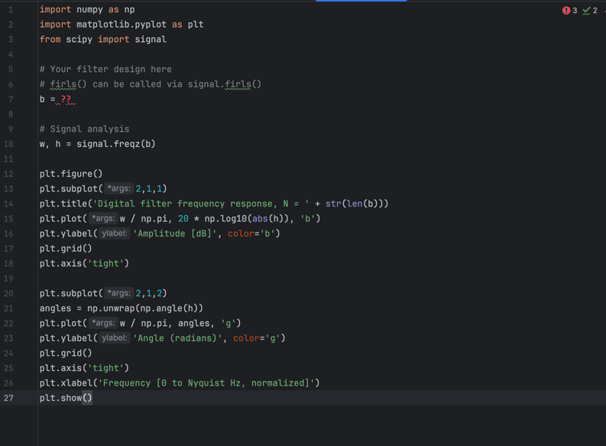

- Attach the plots of your filter design when you are done.
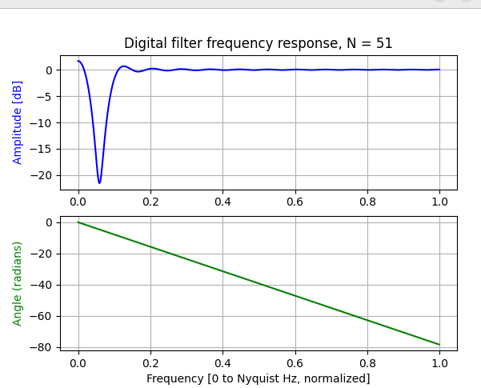
- What is the relation between order and number of taps of an FIR filter?
The number of taps is proportional with the order of the FIR filter, increasing the number of taps will increase the strength of the attentuation.
- Theoretically, you can design any filter if you allow the filter order to go to infinity. What are the practical considerations for using a longer filter?
We want to consider the computational complexity as we increase filter order since we have finite resource usage on CPU and can also increase audio latency which affects the quality of real-time applications.
- In the frequency plots, as you experiment with the number of taps, you will notice that the sharper the transition bands (the frequency ranges where the filter transitions between passband (unity gain) and stopband (attenuation)), the larger the ripple in the passband. Since all other frequencies should pass through with approximately unity gain, your design should minimize the ripples in the pass bands as much as possible.
- Test your filter with this piece of code.
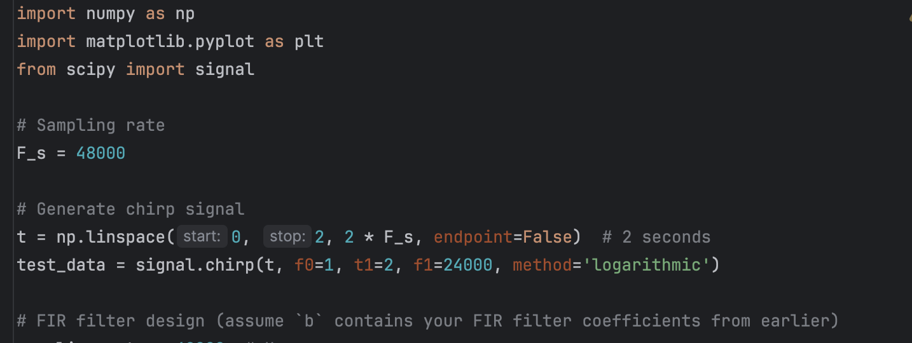
Place your filter design after # FIR filter design (assume `b` contains your FIR filter coefficients from earlier). Continue with the next piece of code.
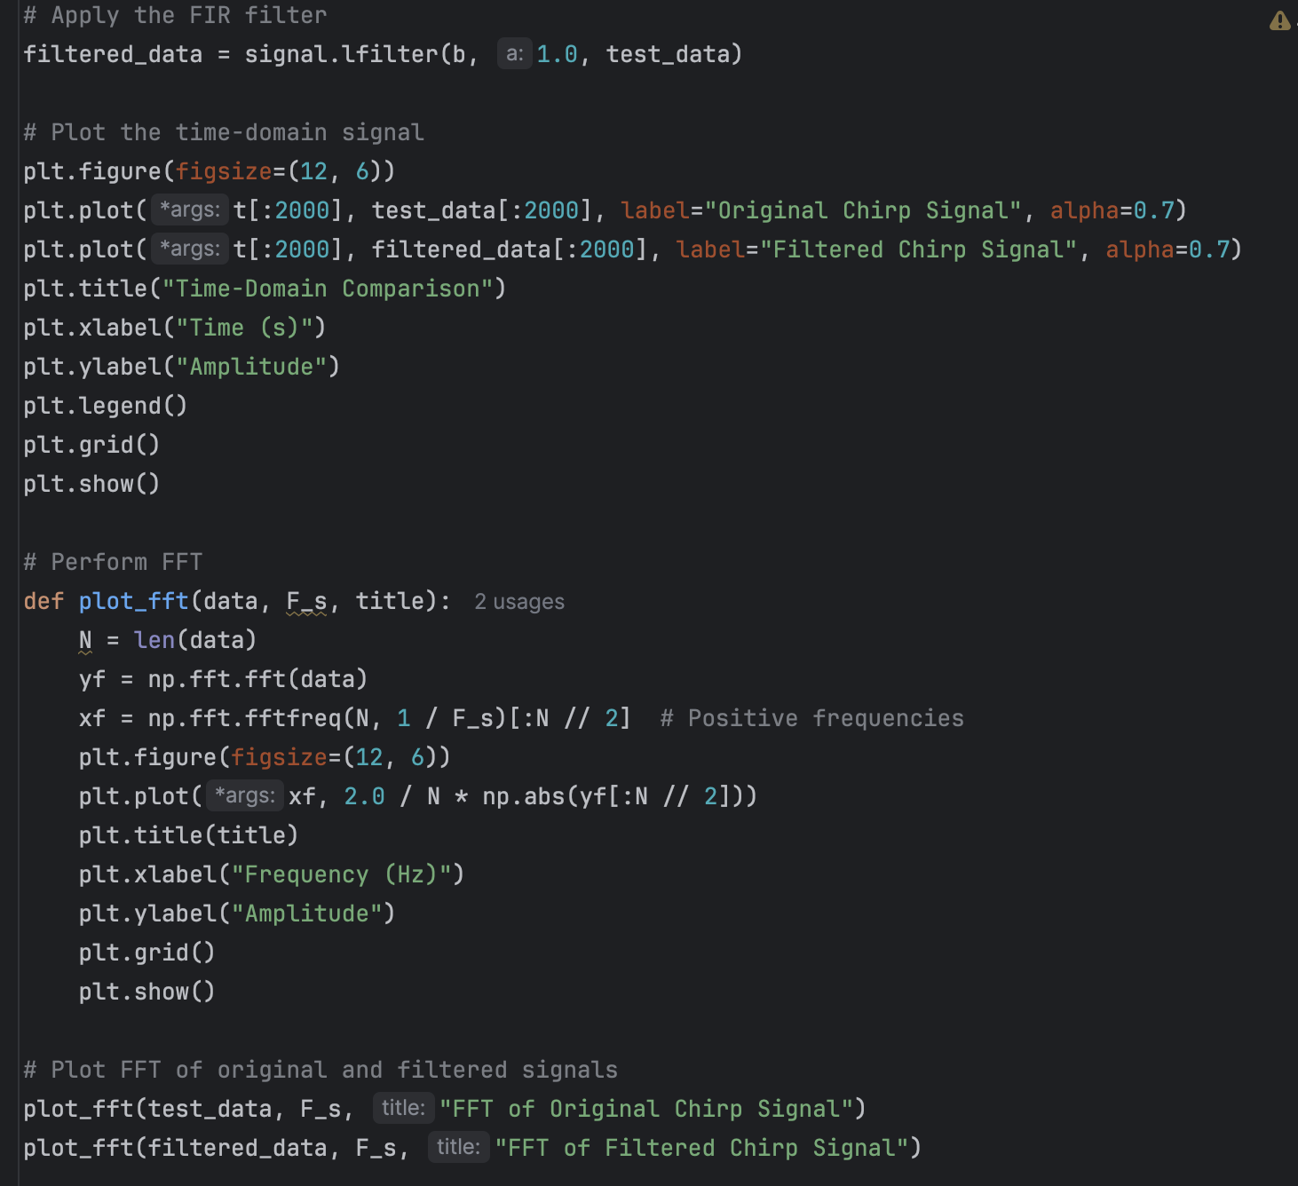
- Attach your results. Does your filter correctly attenuate the frequencies within 1-2khz?
Yes, the filter attenuates the amplitude to about zero around the 1 Khz-2 Khz range indicated by the dip in the graph.
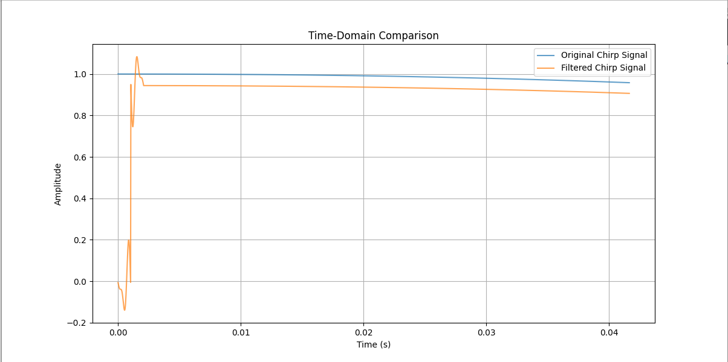

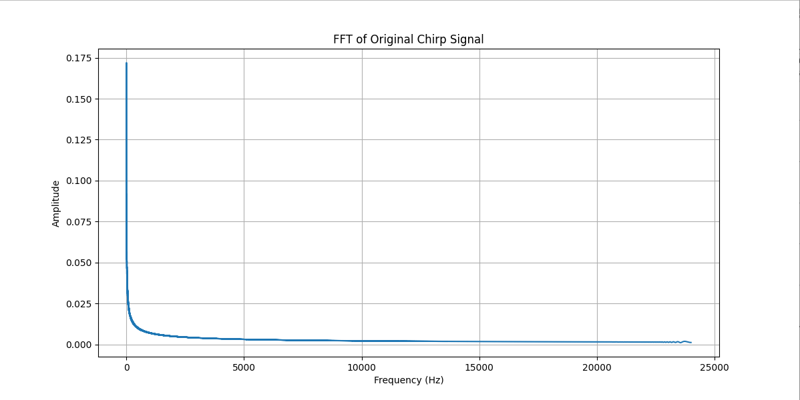

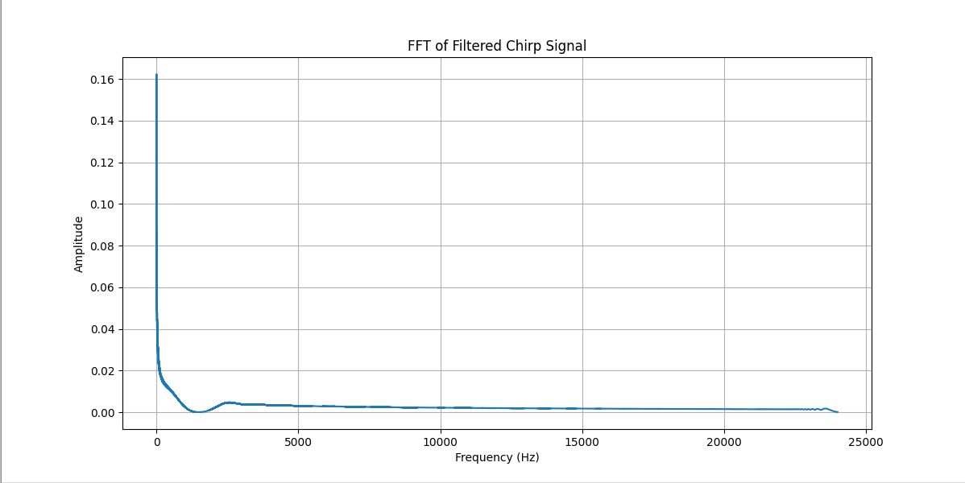

Experiment 3 – FIR VS IIR Comparison
This experiment challenges you to design and compare the performance of FIR and IIR filters. You are tasked with observing the differences in frequency response, phase characteristics, filter order, and transition sharpness, as well as computational efficiency.
- Import the necessary libraries as follows.
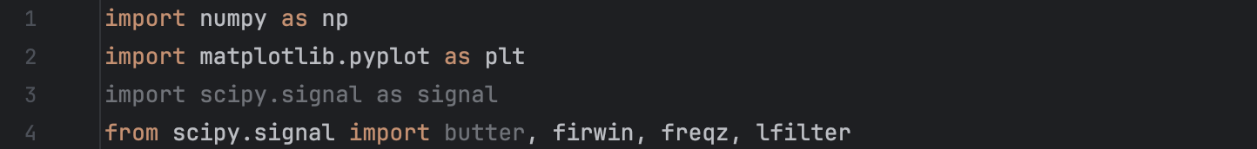
- Generate a signal composed of a clean sine wave and added noise in a specific band. The sampling rate should be 48kHz. In the screenshot, we demonstrate how you should do this with noise of 3kHz; you are free to choose any other noise level you deem fit.
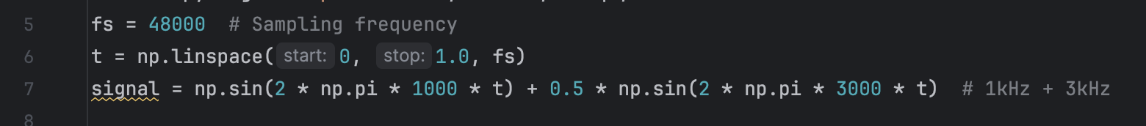
- Plot the generated signal and attach it to your report.

- In this step, we will design an IIR low-pass filter to cutoff noise at least 1khz below the amount of noise added in step 2.
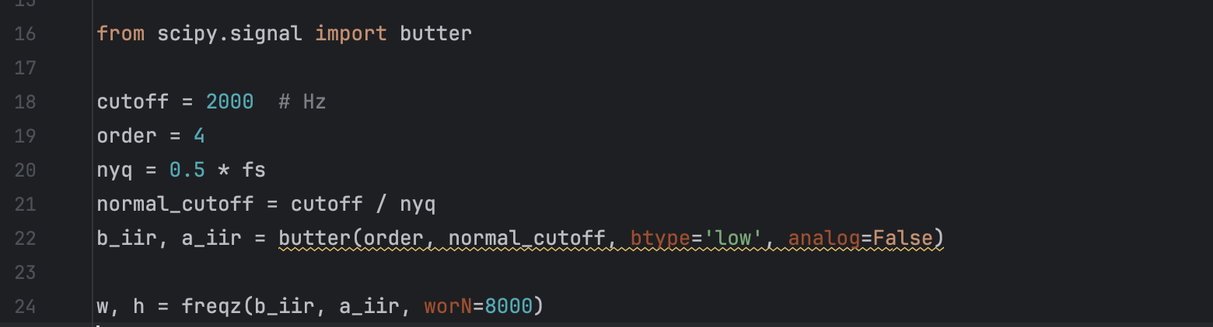
- Plot the frequency response of the IIR filter designed above.
- We will now design and plot the frequency response of the FIR filter using the following piece of code.
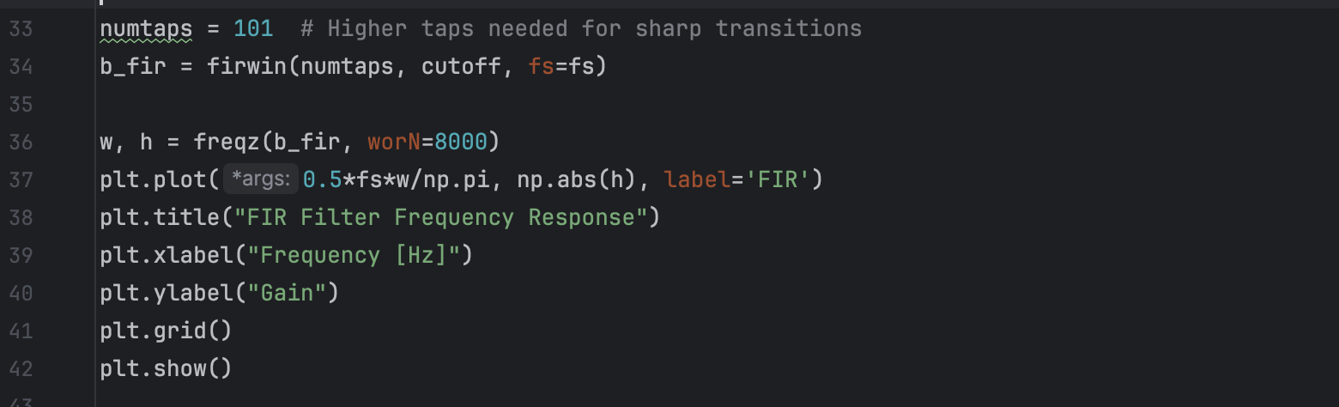
- Attach the plots of the frequency responses of both types of filters to your report.
- Apply both filters using ‘lfilter()’.
- Plot the filtered signals in the frequency domain for the two filters and attach your plots for further analysis and comparison in the assignment below.

Assignment 3
- Attach all the required plots from the experiment conducted above.
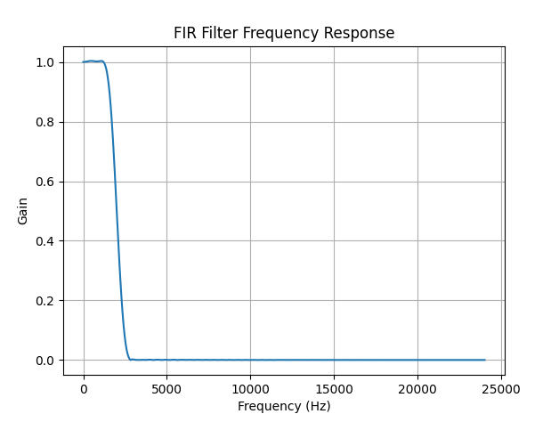
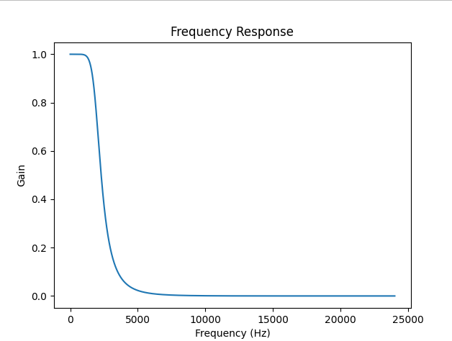
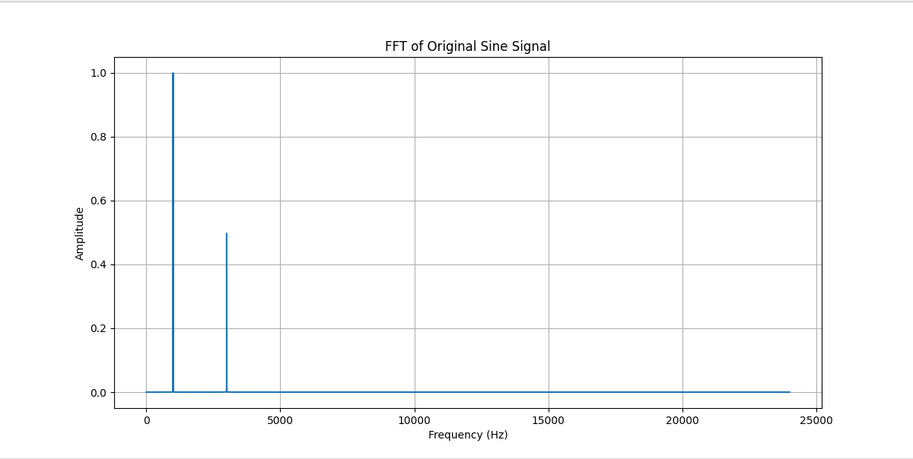
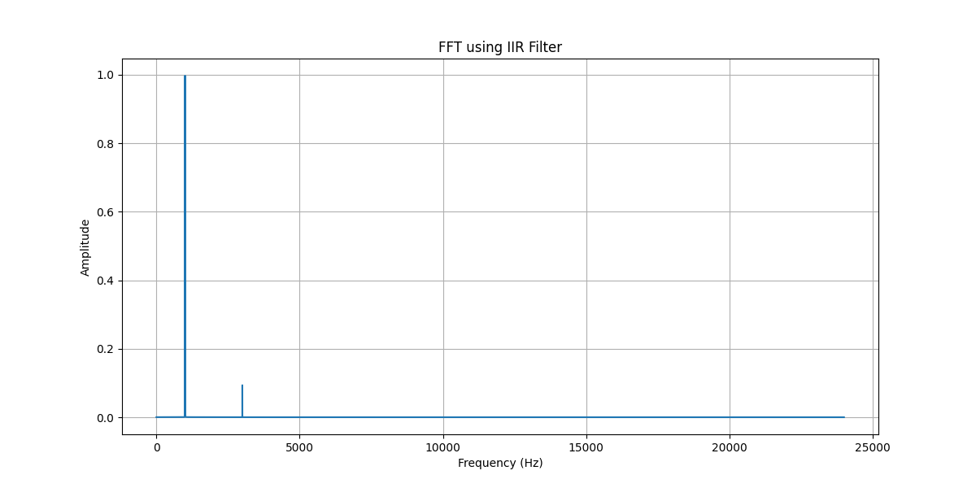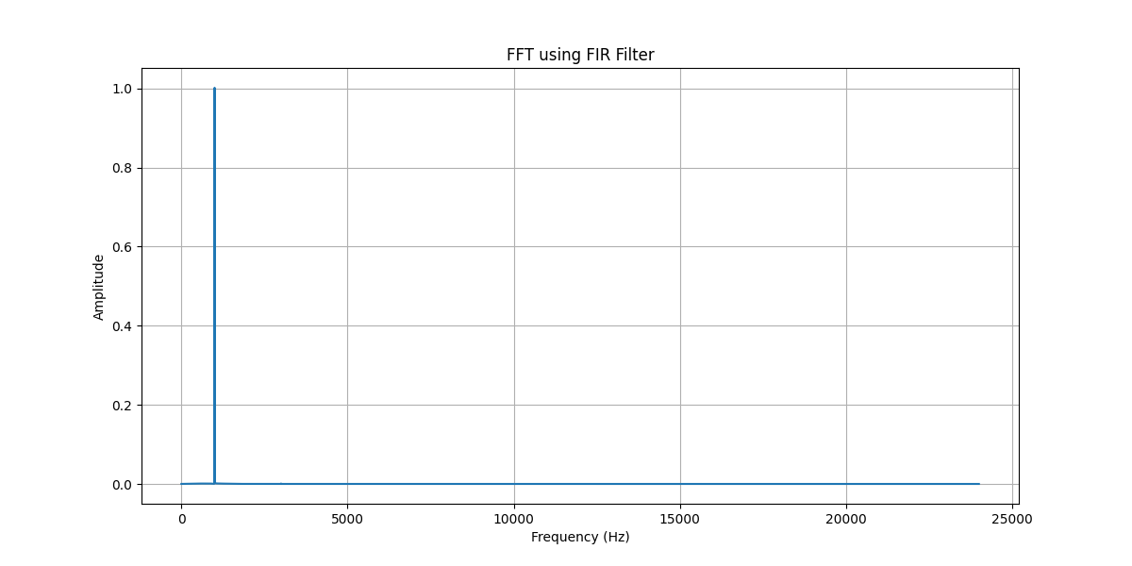
- What the order of the IIR filter used?
Order 4
- How many taps were used in the FIR filter?
101 taps
- What is the relationship between filter order(IIR) and number of taps (FIR)
The FIR is proportional with the IIR, i.e, as the number of taps increases, the order increases.
- You should notice a steepness in the frequency response plots; compare the steepness of the transition band in both responses and determine which filter should attenuate the noise component more effectively.
The FIR filter is more efficient as it is more steep when transitioning while the IIR filter is more gradual when changing gain.
- Visually inspect the time-domain plot(s). Which of the filtered outputs shows less delay, that is, better alignment with the original signal? Explain what the delay means for filtering scenarios.
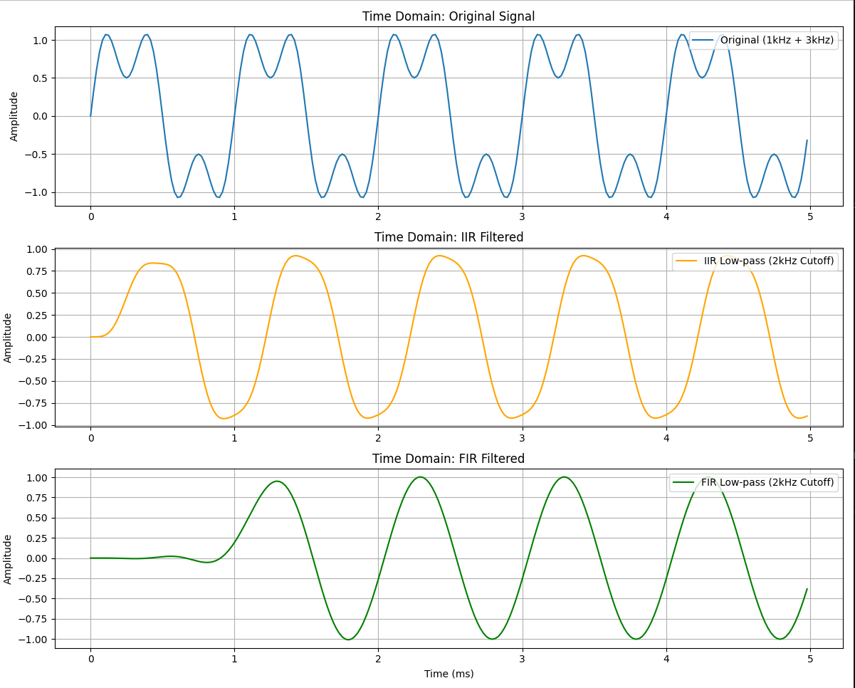
The IIR filtered output shows less delay indicating better performance for real-time speech or communication.

- From your understanding of the experiment, which filter is likely more computationally efficient in real-time applications and why?
The IIR filter would be more computationally efficient which requires only 4 coefficients for computation while the FIR requires 101 coefficients.
- If you were to design a filter for a real-time voice chat app say using Android Studios, which filter (IIR or FIR) would you use and why?
A IIR would be more ideal since it has lower latency which is the most important aspect to consider within a real-time voice chat app. It is also less computationally intensive which means the app would consume less battery life.

Experiment 4 – High pass and Band Pass filters
In the previous experiment, we compared IIR and FIR designs for a low-pass filter and compared the outputs in the time domain. In this section, we will use spectrograms to identify and filter specific components of an audio signal using high-pass and band-pass filters.
- Create a new python file and import the following libraries.
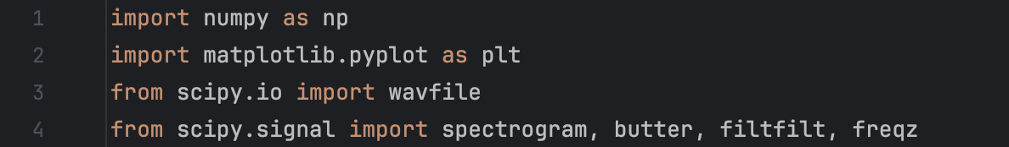
- Load and visualize the “with_hum.wav” file using a spectrogram.
- In this step, we will define a single function to design the two kinds of filters we will be implementing for simplicity.
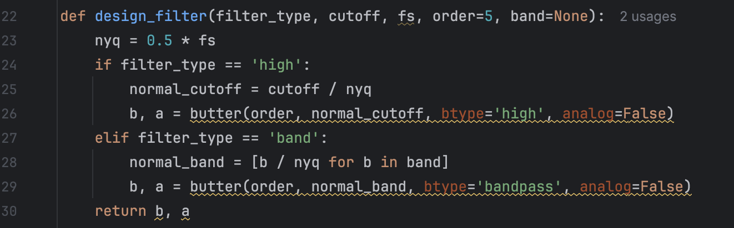
- Now analyze the spectrogram of the audio signal and determine the cutoff frequency to use for the high pass filter.
- Design the highpass filter using the function and the cutoff you determine and plot the frequency response.
- Filter the audio using the high pass filter and plot its spectrogram.
- Analyze the spectrogram of the original signal once more and determine the necessary band that needs to be filtered (kept) for the bandpass filter.
- Design the bandpass filter using the function and the band range you determined and plot the frequency response.
- Filter the audio using the high pass filter and plot the associated spectrogram.

Assignment 4
- Attach all the required plots from the experiment conducted above.
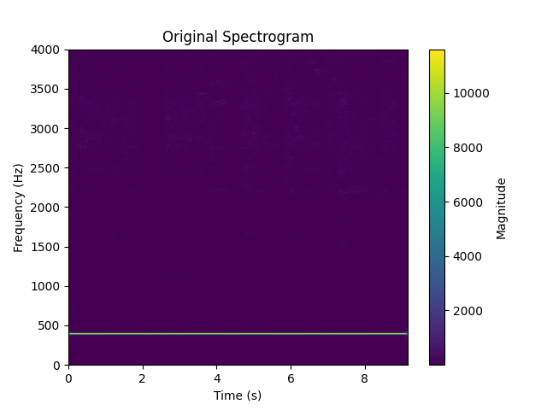
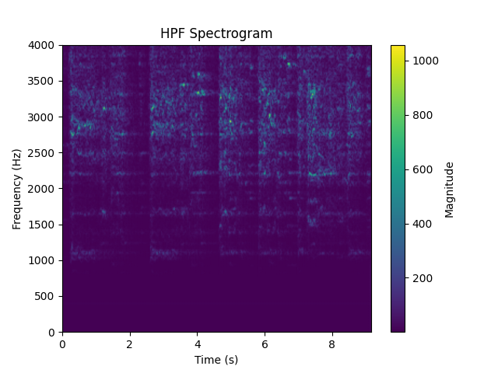
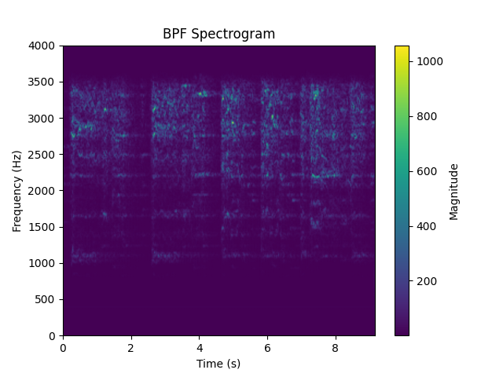
- What components were removed or retained in both cases?
The cutoff frequency for the HPF was 800 Hz and the band of frequencies for the BPF was 800-3,500 Hz.
- In what real-world situations would a high-pass filter be useful?
It’s useful for cleaning out low frequency noise within audio data without affecting the quality.
- When would a band-pass filter be more appropriate?
It’s useful for radios to listen to a specific channel by tuning to a specific frequency.
- Optional – Change the band edges as much as you want and observe the changes by using the spectrogram and playing the audio.

Part 2
This section builds on the previous labs by tasking you with designing a basic Andriod app for filtering.
Assignment 5
- Design an Android app to meet the following targets. You are free in your choice of UI.
  - The app should record an audio signal.
  - Apply a low-pass or high-pass filter to the recorded audio.
  - Include a slider (controller) that allows you to control the filter cutoff frequency.
  - The filtered output should be visualized and be affected by the changes in cutoff frequency.
- What happens as you increase or decrease the cutoff frequency?
- How is this real-time filtering experience different from applying filters in Python?
- What issues could arise from using real-time DSP on mobile devices?
- Attach screenshots of your built app in the report and show the working app to the TA within a week after the submission of the report.

Links
- https://en.wikipedia.org/wiki/Digital_filter - Digital filter
- https://en.wikipedia.org/wiki/Band-stop_filter - Notch/Bandstop filter description
- https://docs.scipy.org/doc/scipy/reference/generated/scipy.signal.butter.html -butter
- https://docs.scipy.org/doc/scipy/reference/generated/scipy.signal.freqz.html - freqz
- https://docs.scipy.org/doc/scipy/reference/generated/scipy.signal.firls.html#scipy.signal.firls – Scipy.signals.firls
- https://en.wikipedia.org/wiki/Finite_impulse_response - FIR filter
- https://en.wikipedia.org/wiki/Infinite_impulse_response - IIR filter
- https://docs.scipy.org/doc/scipy/reference/generated/scipy.signal.lfilter.html - lfilter
- https://en.wikipedia.org/wiki/Band-pass_filter - Band Pass filter
- https://en.wikipedia.org/wiki/Low-pass_filter - Low Pass filter
- https://en.wikipedia.org/wiki/High-pass_filter - High pass filter

